**LowLevel v2.1 PCB**

This document contains:

* Schematic:
* Board layout:
* Assembly guide:
* License:

Wiring Schematic:

* Refer to connections spreadsheet for pin mapping (still in progress)

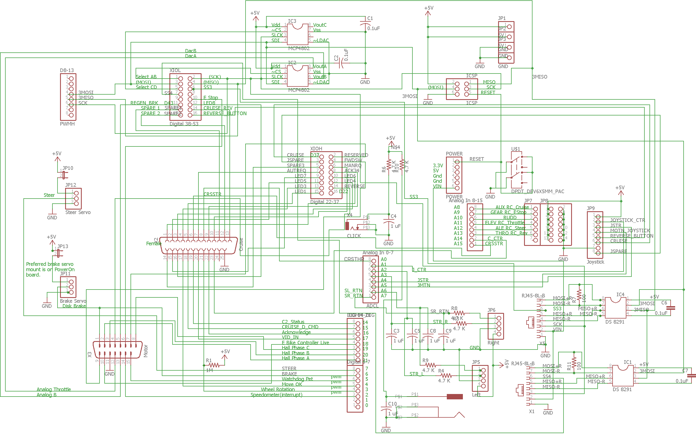

Board Layout:

* Shown without routing for layout purposes

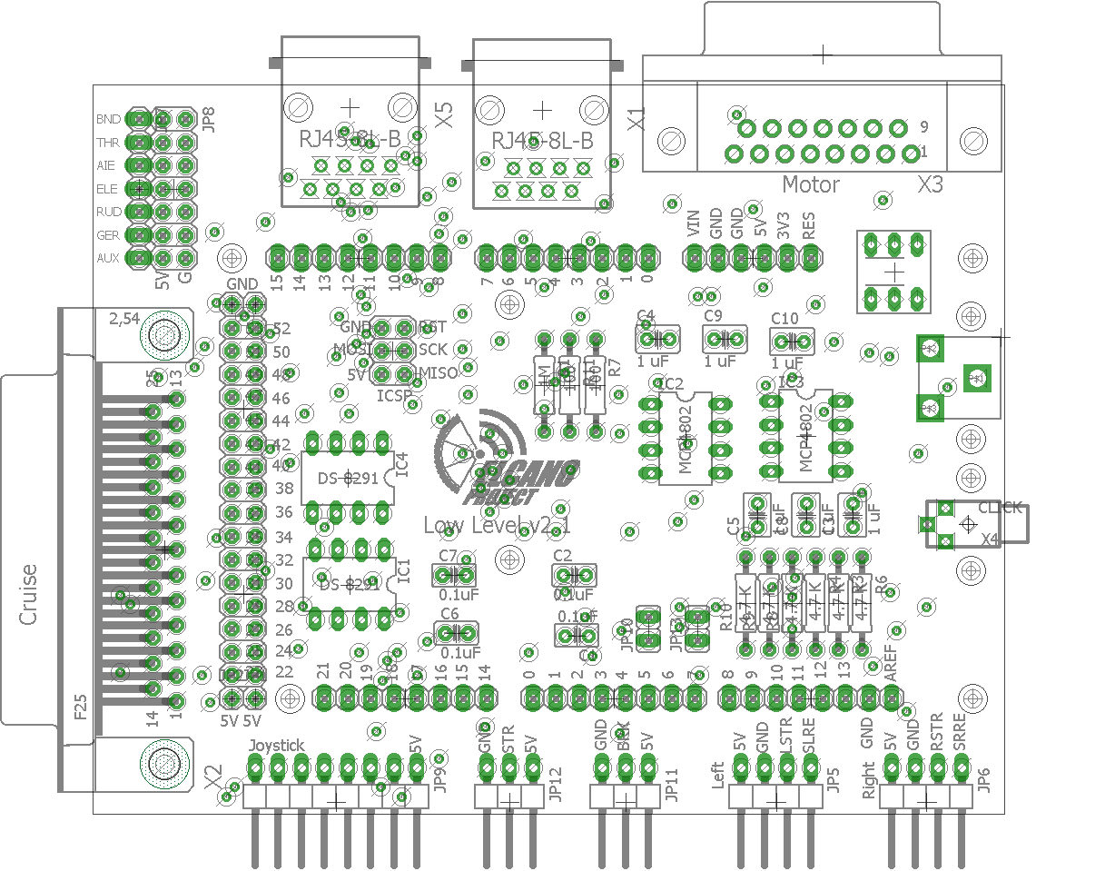

Assembly Guide:

* Begin with soldering on the header connectors for the Arduino, hold them in place with masking tape and make sure they are straight before soldering them on. This ensures proper mating with the microcontroller which is crucial. The female end of the header is on the top of the board and the male ends are on the bottom.

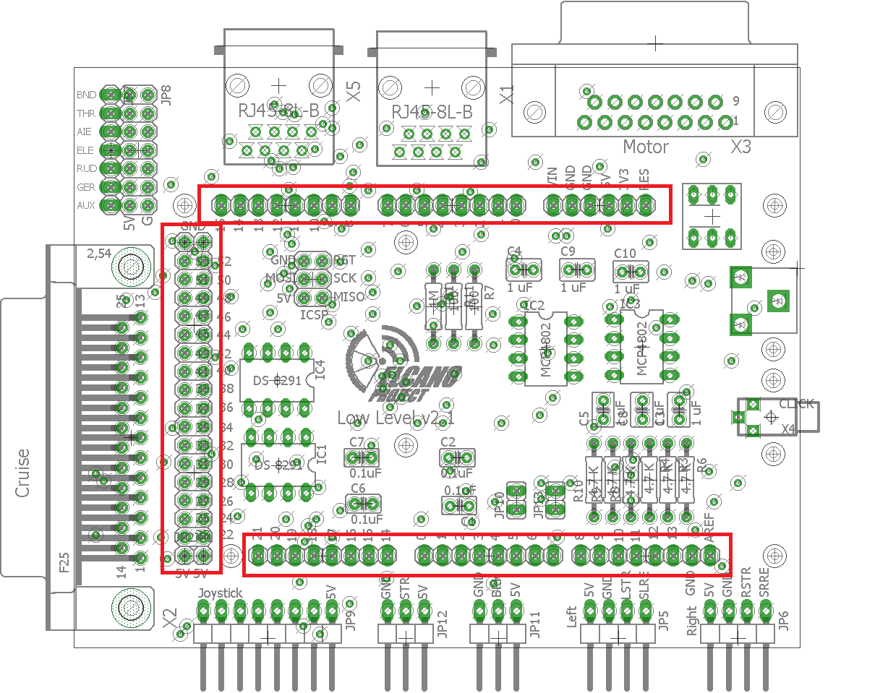

* Next install the peripheral connectors, all of these are mounted on the top of the board. The D-15 connector is male and the D-25 connector is female. Be precise when soldering in the 3 sockets for the RC.
* The connectors on the bottom row can be on the top or bottom side; straight or right angle. The choice depends on the connectors and board mount.

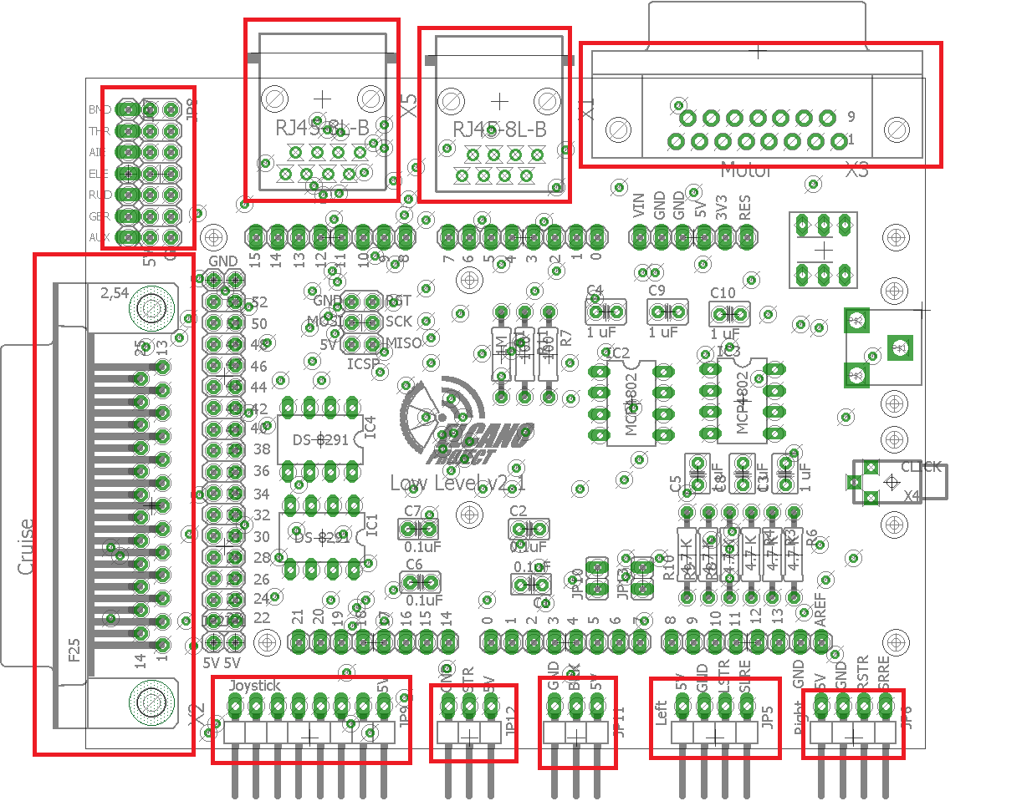

* Next install components:
  + Integrated Circuits
    - Option to solder in sockets first to allow for quick swapping of IC’s.
  + ICSP
    - Pins extending on the top of the board.
  + Reset Switch
    - Align small rectangle on switch with parallel lines on the layout for direction.
    - It may be desirable to leave off the relay switch, since it may occupy space needed for an Arduino shield.
  + Power Jack
    - The holes on the board are big so make sure ample solder is used.

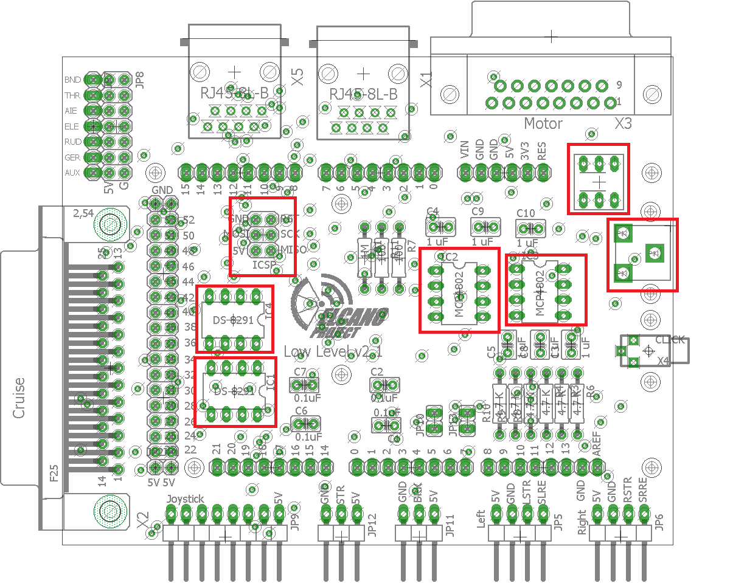

* Finally install resistors capacitors and jumpers
  + Make sure that all parts sit below the level of the Arduino headers so they don’t get in the way.

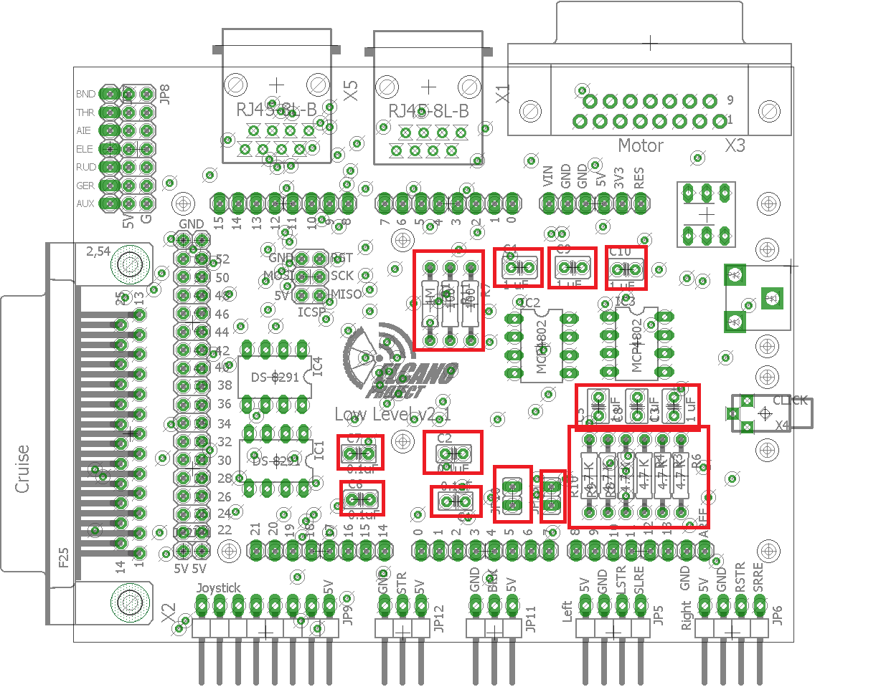

* When you’re finished the board should look like this.

